Please return this document at
Horizon2020@recherche.gouv.fr
Partner search
Date (DD-MM-YY)
- (*) Indicate numbers of relevant topics for Green Deal call:
LC-GD-8-1-2020

- Quick description of the project
Unique porous ceramic-like floating carriers covered with highly efficient photocatalytic nanoparticles for advanced wastewater remediation

Various heterogeneous porous carriers with catalytic properties used in science and different technologies are available. However, a class of porous inorganic materials with density enabling them to float in water is missing. This proposal addresses investigation of an innovating route to synthesis of the water-floatable porous ceramic-like bodies whose properties are enhanced by laser-coating the whole porous surface with nano-sized catalytic particles efficient for degradation of organic compounds. Ceramic-like porous catalytic carrier will be synthesized from aluminosilicate materials through sol-gel method to the form of hollow spherical beads. The floating lightweight spherical carriers will be covered with high efficient nanoparticles with photocatalytic activity under the daily sunlight without need of H₂O₂ addition and external source of UV irradiation. Study and characterization of formed structures with respect to their photocatalytic activity will be performed. The coated porous carriers will be examined for their efficiency in solar-light driven degradation of water-soluble pollutants.

Key words : Water remediation; Photocatalysis; Porous carriers; Nanoparticles

- (*) Do you intend to apply as ? :
Coordinator: Yes/No
Participant: Yes/No

(*) Either Description of the expertise requested (up to 1000 characters) - specify which points of the "expected impact" of the call you are targeting
We are looking for partners in a research project who deal with similar issues of wastewater treatment.
The topic of cooperation may be:
- Joint development in the field of materials chemistry
- Characterization of the resulting products
- Testing the effectiveness of carriers and degradation of organic pollutants
- Characterization of formed structures with respect to their photocatalytic activity.
- Testing of floating carriers from the perspective of their efficiency, stability and revitalization.

Key words : Water remediation; Photocatalysis; Porous carriers; Nanoparticles

Or Description of the expertise proposed (up to 1000 characters) - specify which points of the "expected impact" of the call you are targeting
Our group is experienced in synthesis of porous materials/carriers, nanosized catalytic particles and their characterization (structural, thermal and surface properties).
Due to the resistance of the most organic molecules (e.g. dyes, Cl⁻ and NO_{x} containing molecules) the photodegradation with combination with traditional adsorption process is considered as the efficient way to completely remove hazardous organic molecules from water. A floating and coated catalytic carrier with a defined porous surface is a suitable alternative with a rugged surface that might result in high efficiency capability as shown in Fig. 1.
The ability to float / move the carrier and thus ensure a high degree of efficiency of the photocatalytic effect is considered to be a significant advantage.

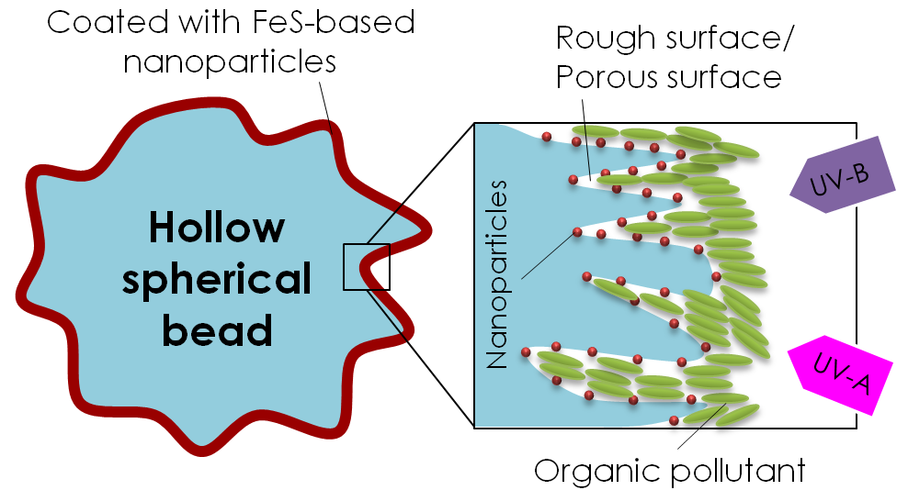
Fig. 1. Schematic representation of photodegradation of adsorbed organic molecules on a hollow carrier with a catalytic coating.

Key words : Water remediation; Photocatalysis; Porous carriers; Nanoparticles

Organisation information
Organisation and country:
| New Technologies - Research Centre | https://ntc.zcu.cz/en/
University of West Bohemia, Univerzitní 8, 30614 Plzeň, Czech Republic
Type of organisation:
□ Enterprise □ SME □ Academic □Research institute □ Public Body □ Other: Association
Former participation in FP European projects?
□ Yes □ No
Web address:
https://ntc.zcu.cz/en/
Description of the organisation:
NTC - focuses on research and solutions for green technologies and advanced materials. Since 2020 NTC is an independent self-financed institute of the University of West Bohemia. It is equipped with cutting edge research technologies and facilities. Experienced, reliable and dedicated multinational team of more than 130 researchers conduct basic and applied research, development and innovations for industrial applications mainly in the following areas: laser technologies; thermography-thermometry; new materials’ development and materials’ testing; development of new polymer composites; measurement and simulation of deformations and dynamic processes; measurement and simulation of temperatures’ fields and heat transfer; measurement and simulation of complex fluid flow; new thin-layer materials (photovoltaics, photonics, microsystems), energy storage systems; biomechanical models of humans
Our teams provide cutting edge research and interdisciplinary solutions across the entire value chain – from the idea to the prototype. Our researchers have published prestigious articles e.g. in Nature Communications, have patented their solutions and successfully applied innovative technologies and results in various industries around the world.
NTC co-operates with dozens of domestic and as well as international industrial companies on solving their technical and technological problems. NTC partners with renowned research institutions and professional organizations. Participates in EU and other grant programmes worldwide.

(*) Contact details
Contact person name | Ing. Tomáš Kovářík Ph.D.
Telephone | +420 702 210 188
E-mail | toko@ntc.zcu.cz
Country | Czech Republic

(*) –Mandatory

