Please return this document at
Horizon2020@recherche.gouv.fr
Partner search
Date (31.08.2020)
- (*) Indicate numbers of relevant topics for Green Deal call:
LC-GD-1.2: Towards Climate Neutral & socially innovative cities
LC-GD-9.1: European Research Infrastructures capacities and services to address European Green Deal challenges
LC-GD-9.2: Developing end-user products and services for all stakeholders and citizens supporting climate adaptation and mitigation
LC-GD-10.1: 10.1 European capacities for citizen deliberation and participation for the Green Deal
LC-GD-10.2: Behavioural, social and cultural change for the Green Deal
LC-GD-10.3: Enabling citizens to act on climate change and environmental protection through education, citizen science, observation initiatives, and civic involvement

- Quick description of the project
(describe the objectives, activities, partners requested and their skills)

- (*) Do you intend to apply as ? :
Coordinator: No
Participant: Yes

(*) Either Description of the expertise requested (up to 1000 characters) - specify which points of the "expected impact" of the call you are targeting
+ key words :

Or Description of the expertise proposed (up to 1000 characters) - specify which points of the "expected impact" of the call you are targeting
The team from the Pavol Jozef Šafárik University in Košice, Faculty of Public Administration has several experiences in cooperation with official authorities, municipalities and other universities and research facilities at national and international level. The team interested in this call can provide expertise in the field of public administration, public policy, self-government, cooperation of bigger cities and smaller surrounding municipalities, city regions, ethics in public administration, engagement of citizens, identification of stakeholders in concrete environment, eGovernment, provision of eServices at the municipality level, smart cities, strategic planning and output oriented management in municipalities, development of educational programmes.

The team targets mainly contributing to the impacts:
1.2: cross-sectoral governance, citizens participations, social innovation and social entrepreneurship impact, policy approaches, urban digital platform.
9.1: synergies among research infrastructure including social sciences, development of new generation of researchers in the social sciences field addressing EGD challenges.
9.2: decision making and policy making of citizens, stakeholders decision-makers focusing on EGD challenges. Active role of different stakeholders in policy making and evidence based policy making, based on knowledge and information.
10.1: involvement of citizens in the implementation of the EGD. Stronger trust in policy makers, policy making, policies on EGD issues.
10.2: changes and systematic changes of public administration, especially policy makers, in line with ethical standards in order to succeed with EGD.
10.3: development of educational programmes, courses, curricula, trainings. Focus on all levels of higher education, including children university, lifelong learning, etc. Exchange of best practices. Cooperation with Cities and Stakeholders in the Slovak Republic and related to the Consortium.

+key words: Green Deal, Governance, Citizens, Cities, Public Engagement, Public Policy Making, Participatory Policy Making, Stakeholders, Public Administration, Ethics

Organisation information
Organisation and country:
Pavol Jozef Šafárik University in Košice, Slovakia
Type of organisation:
□ Enterprise □ SME □ Academic □Research institute □ Public Body □ Other: Association
Former participation in FP European projects?
□ Yes □ No
Web address:
https://www.upjs.sk/en/?prefferedLang=EN
Description of the organisation:
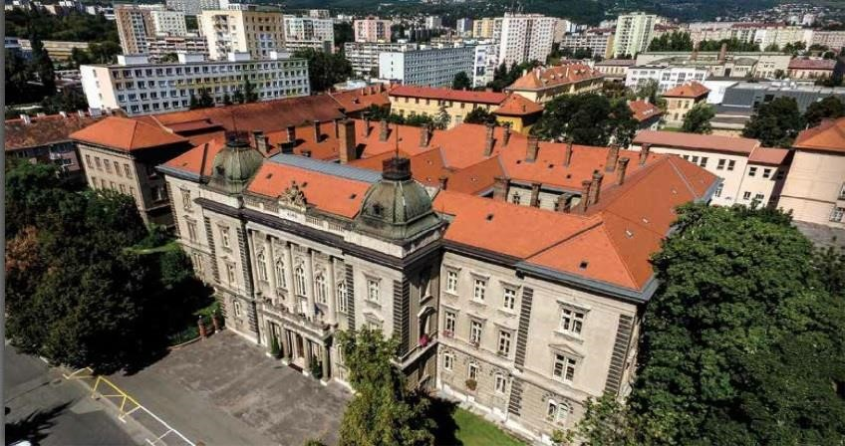
Pavol Jozef Safarik University in Kosice (UPJS) https://www.upjs.sk/en/?prefferedLang=EN

UPJS established in 1959, is the second-largest classical Slovak university with five faculties (Medicine, Science, Law, Public Administration, Arts) and approximately 7500 students and 650 teachers/researchers.
The recent reports of the several Academic Ranking and Rating Agencies confirm that the quality of research outputs from the UPJS is increasing and that the University belongs amongst the three best Research universities in Slovakia https://www.upjs.sk/en/university/international-relations/Rankings/
Research infrastructure of the UPJS in the previous years (2010-2019) has been upgraded by the implementation of 17 projects within the National Operational Program Research and Development (OPRD), which is an implementation strategy of European Cohesion Policy defined in the official National Strategic Reference Framework 2007-2013 and 2014-2020 negotiated with EC. Individual laboratories from UPJS have participated in FP5, FP6, FP7 and H2020 projects.
UPJS signed the Strategic Framework for Gender Equality Policy at UPJS in Kosice. https://www.upjs.sk/en/university/strategic-framework/

The Faculty of Public Administration was established in 1998 as the only faculty of its kind in the Slovak Republic higher educational system. The educational focus of the Faculty is in the study field Political sciences oriented on study programmes public administration and European public administration at all 3 levels of higher education. The Faculty is member of The Network of Institutes and Schools of Public Administration in Central and Eastern Europe, which connects universities, institutions and individuals with the goal to strengthen and to promote effective and democratic governance and modernization of public administration and policy. The Faculty closely cooperates with more than 30 universities from the EU and beyond in the area of joint research, education, project activities. The Faculty has developed long-term relations with national government institutions and with self-government bodies, resulting in expertise and consultancy activities. The research focus is on juridical, economic and social aspects of public administration, public policy theory and public policy making, ethics in public administration, introduction of modern ICT based solutions within public management, smart city, governance models, etc. The Faculty is a well-recognised institution within the interuniversity environment, but also wider in national and international higher education environment.

Competences relevant to the project
UPJS has the “University department Lifelong Learning Centre and Project Support”, dedicated to supporting H2020 projects. The UPJS provides a stimulating research environment for its research community with access to dedicated research support staff and has the administrative capacity to project management. The UPJS has a full-time Development Officer whose role includes providing high level and intensive support to manage, administer and co-ordinate major research projects within the Institute including the timely delivery of reports to funding bodies as well as project management expertise to support individual researchers and teams. The Development Officer will work with the project implementation team and the research team to support the effective delivery of the research programme and to work with both in seeking complimentary research funding to enhance the research activities. The team will also be provided with high-level support to increase the visibility and impact of their scholarship activities which are aimed at maximising the researchers’ scholarship outputs. Support staff at the UPJS will also work with researchers and the scientist in charge of a customised research visibility strategy targeted at international academic, policy and practice stakeholders. The UPJS also has a full-time Administrator who will provide high-level administrative support to the researcher. All researchers will be provided with a designated office space and will be provided with the necessary equipment to carry out their research project i.e. computer, printer, telephone and software requirements.
Please see link below:
https://www.upjs.sk/en/departments/lifelong-learning-centre-and-projects-support/

(*) Contact details
Contact person name | Silvia Ručinská
Telephone | +421 55 234 1164
E-mail | silvia.rucinska@upjs.sk
Country | Slovakia

(*) –Mandatory

